**Sound Board Quick Guide**

**Channels**

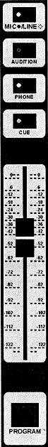**Mic / Line:** *The light on this button should always be off*.

**Audition:** Pressing this allows you to preview this channel with the Audition button (located under Ctrl. Room. )

**Phone:** Pressing this allows the person on the phone to hear this channel

**Cue:** Similar to Audition, pressing this allows you to preview this channel with the Cue button (located under Ctrl. Room.)

**Fader:** Controls the volume for Program, Audition and Cue

**Program:** Puts the channel on the air.

|  |  |  |  |
| --- | --- | --- | --- |
| Ctr. Room.png | **Ctrl. Room Monitors**  **Mon:** Volume for the in studio monitors (speakers)  **HPhone:** Master volume for the headphones  **Program:** Allows you to hear what is on the air  **Audition:** Allows you to preview in studio all channels that have Audition turned on.  **Cue:** Allows you to preview in studio all channels that have Cue turned on. | Phone.png | **Phone**  **Off Hook:** Answers the phone  **Ring:** Lights up and buzzes when there is an incoming call  **Send:** Controls the volume that the caller hears (note: the caller will only hear channels with phone turned on)  **Return:** Controls the volume that the listener hears.  **Program:** Puts the caller on air  **Audition:** Allows you to screen the caller on the Audition channel (this will not put them on the air)  **Cue:** Allows you to screen the caller on the Cue channel (this will not put them on the air) |